Week 2 - Spring Core and Maven

Exercise 1: Configuring a Basic Spring Application
Solution Code:
BookService.java:
package com.library.service;

import com.library.repository.BookRepository;

public class BookService {
private BookRepository bookRepository;

public void setBookRepository(BookRepository bookRepository) {
this.bookRepository = bookRepository;
}

public void executeService() {
System.out.println("BookService layer executing...");
bookRepository.saveBook();
}
}
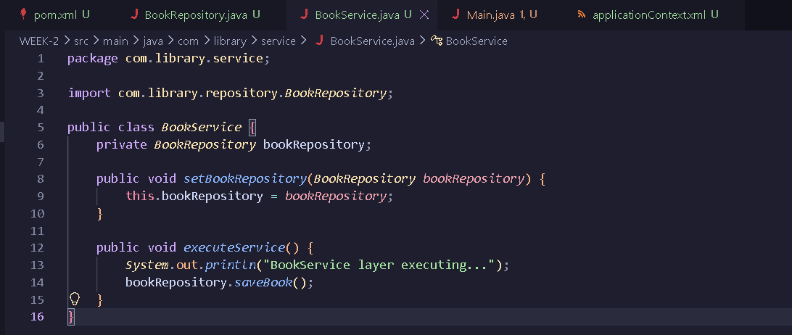
BookRepository.java:
package com.library.repository;

public class BookRepository {
public void saveBook() {
System.out.println("Book saved successfully to the database by Aditya's repository!");
}
}
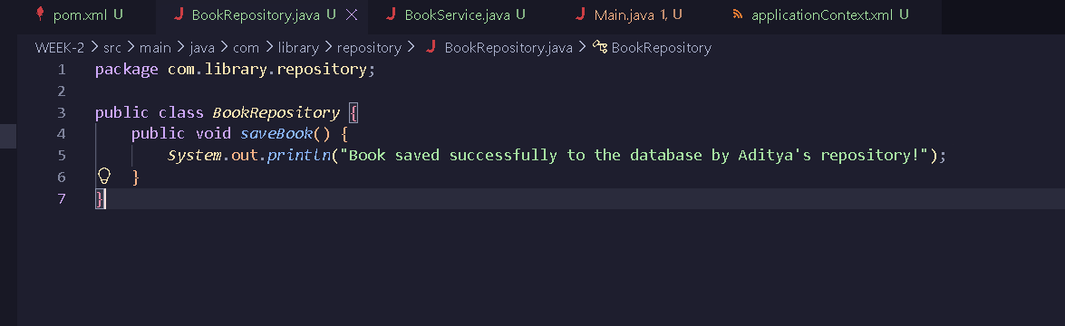

Main.java:
package com.library;

import org.springframework.context.ApplicationContext;
import org.springframework.context.support.ClassPathXmlApplicationContext;
import com.library.service.BookService;

public class Main {
public static void main(String[] args) {

ApplicationContext context = new ClassPathXmlApplicationContext("applicationContext.xml");

BookService bookService = (BookService) context.getBean("bookService");

bookService.executeService();
}
}
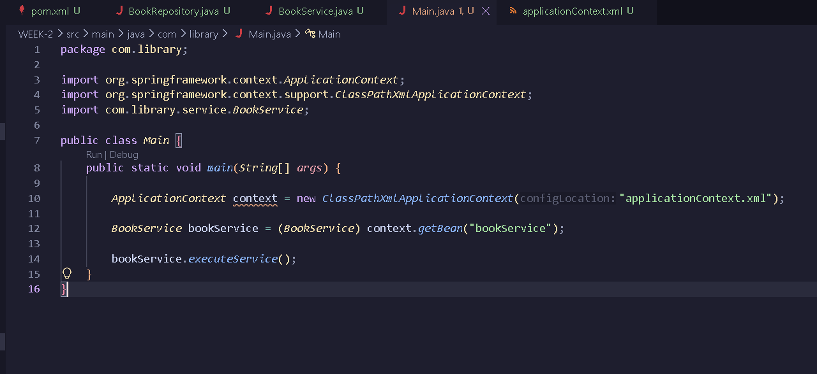

applicationContext.xml:
<?xml version="1.0" encoding="UTF-8"?>
<beans xmlns="http://www.springframework.org/schema/beans"
xmlns:xsi="http://www.w3.org/2001/XMLSchema-instance"
xsi:schemaLocation="http://www.springframework.org/schema/beans
http://www.springframework.org/schema/beans/spring-beans.xsd">

<bean id="bookRepository" class="com.library.repository.BookRepository" />

<bean id="bookService" class="com.library.service.BookService">
<property name="bookRepository" ref="bookRepository" />
</bean>

</beans>

Output:
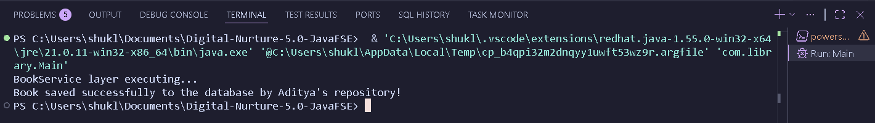

Exercise 2 - Implementing Dependency Injection
Solution Code:
BookService.java:
package com.library.service;

import com.library.repository.BookRepository;

public class BookService {
private BookRepository bookRepository;

public void setBookRepository(BookRepository bookRepository) {
this.bookRepository = bookRepository;
}

public void executeService() {
System.out.println("Book Service Called");
bookRepository.saveBook();
}
}
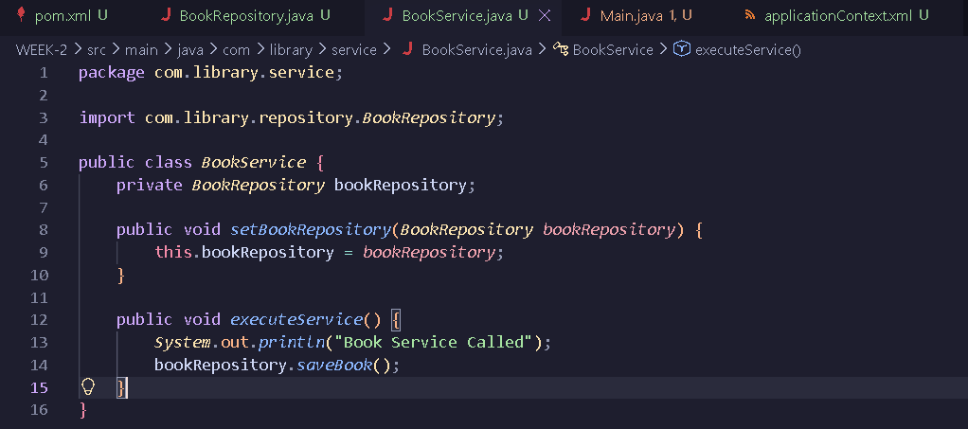

BookRepository.java:
package com.library.repository;

public class BookRepository {
public void saveBook() {
System.out.println("Fetching books from repository...");
}
}
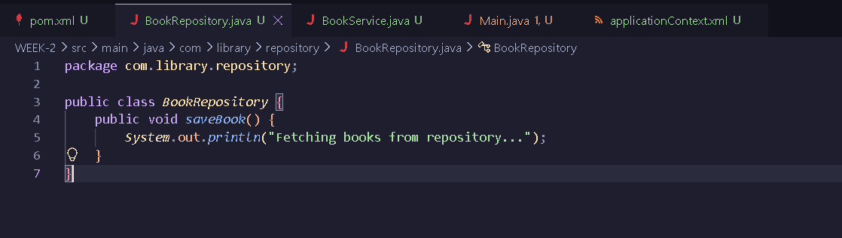

Main.java:
package com.library;

import org.springframework.context.ApplicationContext;
import org.springframework.context.support.ClassPathXmlApplicationContext;
import com.library.service.BookService;

public class Main {
public static void main(String[] args) {

ApplicationContext context = new ClassPathXmlApplicationContext("applicationContext.xml");

BookService bookService = (BookService) context.getBean("bookService");

bookService.executeService();
}
}
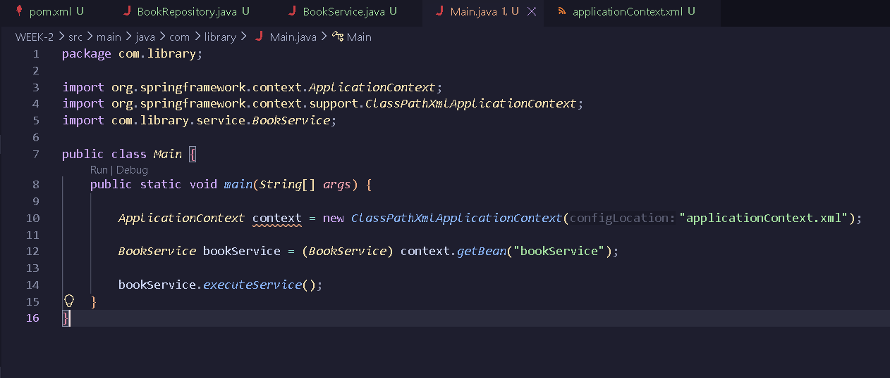

applicationContext.xml:
<?xml version="1.0" encoding="UTF-8"?>
<beans xmlns="http://www.springframework.org/schema/beans"
xmlns:xsi="http://www.w3.org/2001/XMLSchema-instance"
xsi:schemaLocation="http://www.springframework.org/schema/beans
http://www.springframework.org/schema/beans/spring-beans.xsd">

<bean id="bookRepository" class="com.library.repository.BookRepository" />

<bean id="bookService" class="com.library.service.BookService">
<property name="bookRepository" ref="bookRepository" />
</bean>

</beans>
Output:
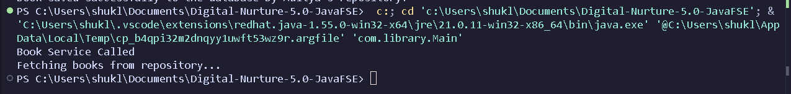

Exercise – 4: Creating and Configuring a Maven Project
Solution Code:
pom.xml:
<?xml version="1.0" encoding="UTF-8"?>
<project xmlns="http://maven.apache.org/POM/4.0.0"
xmlns:xsi="http://www.w3.org/2001/XMLSchema-instance"
xsi:schemaLocation="http://maven.apache.org/POM/4.0.0 http://maven.apache.org/xsd/maven-4.0.0.xsd">
<modelVersion>4.0.0</modelVersion>

<groupId>com.library</groupId>
<artifactId>LibraryManagement</artifactId>
<version>1.0-SNAPSHOT</version>

<properties>
<project.build.sourceEncoding>UTF-8</project.build.sourceEncoding>
</properties>

<dependencies>
<dependency>
<groupId>org.springframework</groupId>
<artifactId>spring-context</artifactId>
<version>5.3.29</version>
</dependency>

<dependency>
<groupId>org.springframework</groupId>
<artifactId>spring-aop</artifactId>
<version>5.3.29</version>
</dependency>

<dependency>
<groupId>org.springframework</groupId>
<artifactId>spring-webmvc</artifactId>
<version>5.3.29</version>
</dependency>
</dependencies>

<build>
<plugins>
<plugin>
<groupId>org.apache.maven.plugins</groupId>
<artifactId>maven-compiler-plugin</artifactId>
<version>3.8.1</version>
<configuration>
<source>1.8</source>
<target>1.8</target>
</configuration>
</plugin>
</plugins>
</build>
</project>
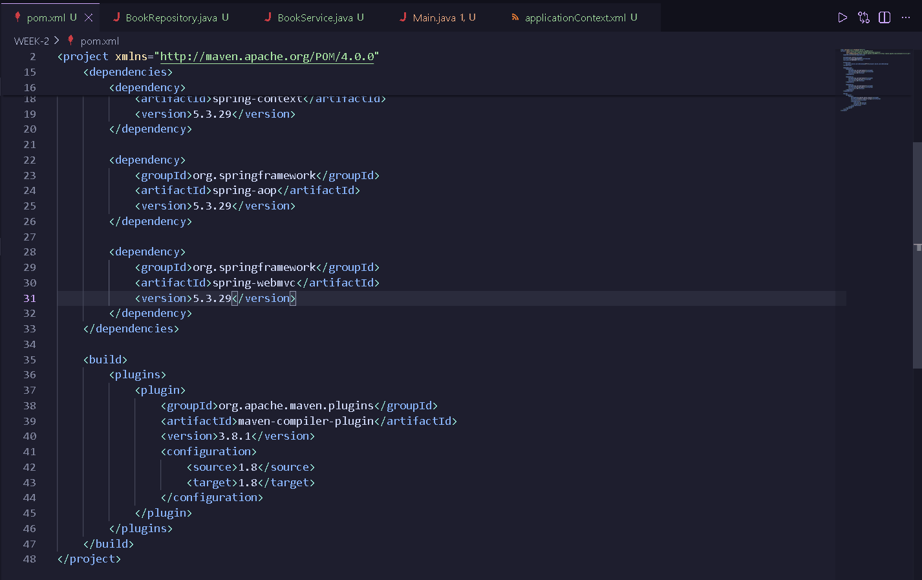

Output:
